Ideation Phase
Define the Problem Statements

Date | 25 June 2025
Team ID | LTVIP2026TMIDS65735
Project Name | Flightfinder
Maximum Marks | 2 Marks

Customer Problem Statement for Flight Finder
To define the core problems travellers and operators face while booking or managing flights online, and use those insights to guide the development of Flight Finder.
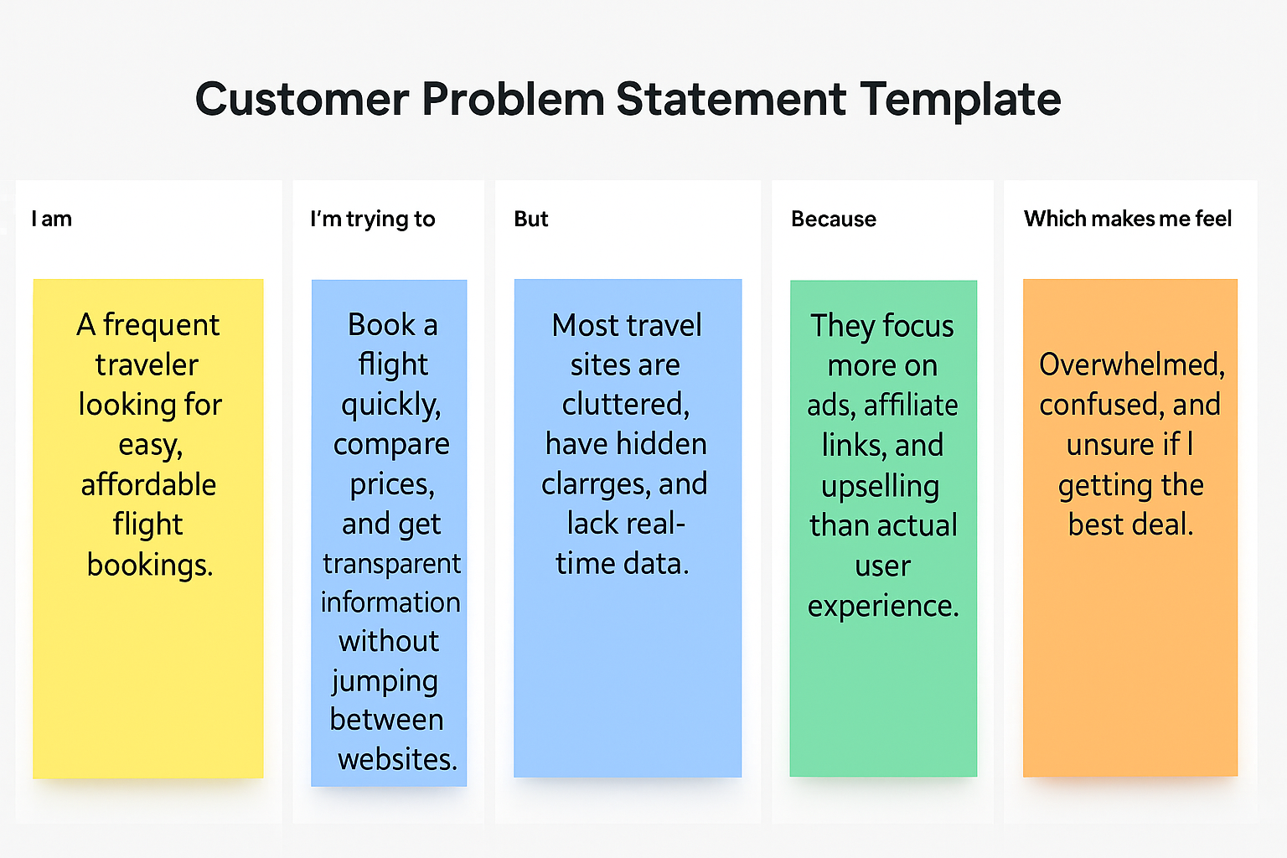

Problem Statement(PS) | I am  (Customer) | I’m trying to | But | Because | Which makes me feel
PS-1 | a busy working professional who often travels for work and leisure | find and book affordable flights easily with real-time info | most flight sites are cluttered or have hidden charges | they prioritize advertising and commissions over user convenience | frustrated, rushed, and unsure if I’m getting the best deal
PS-2 | a flight operator or admin managing multiple daily flights | update flight info, view bookings, and track customer requests | existing systems are too expensive or not tailored to needs | they lack real-time, customizable tools suited for smaller operators | overwhelmed and unable to offer smooth and efficient service

